**"Day 4 - Dynamic Frontend Components - [Muniba e-shop]"**

**Product Listing Component:**

Product List with filter of New ceramic tag.

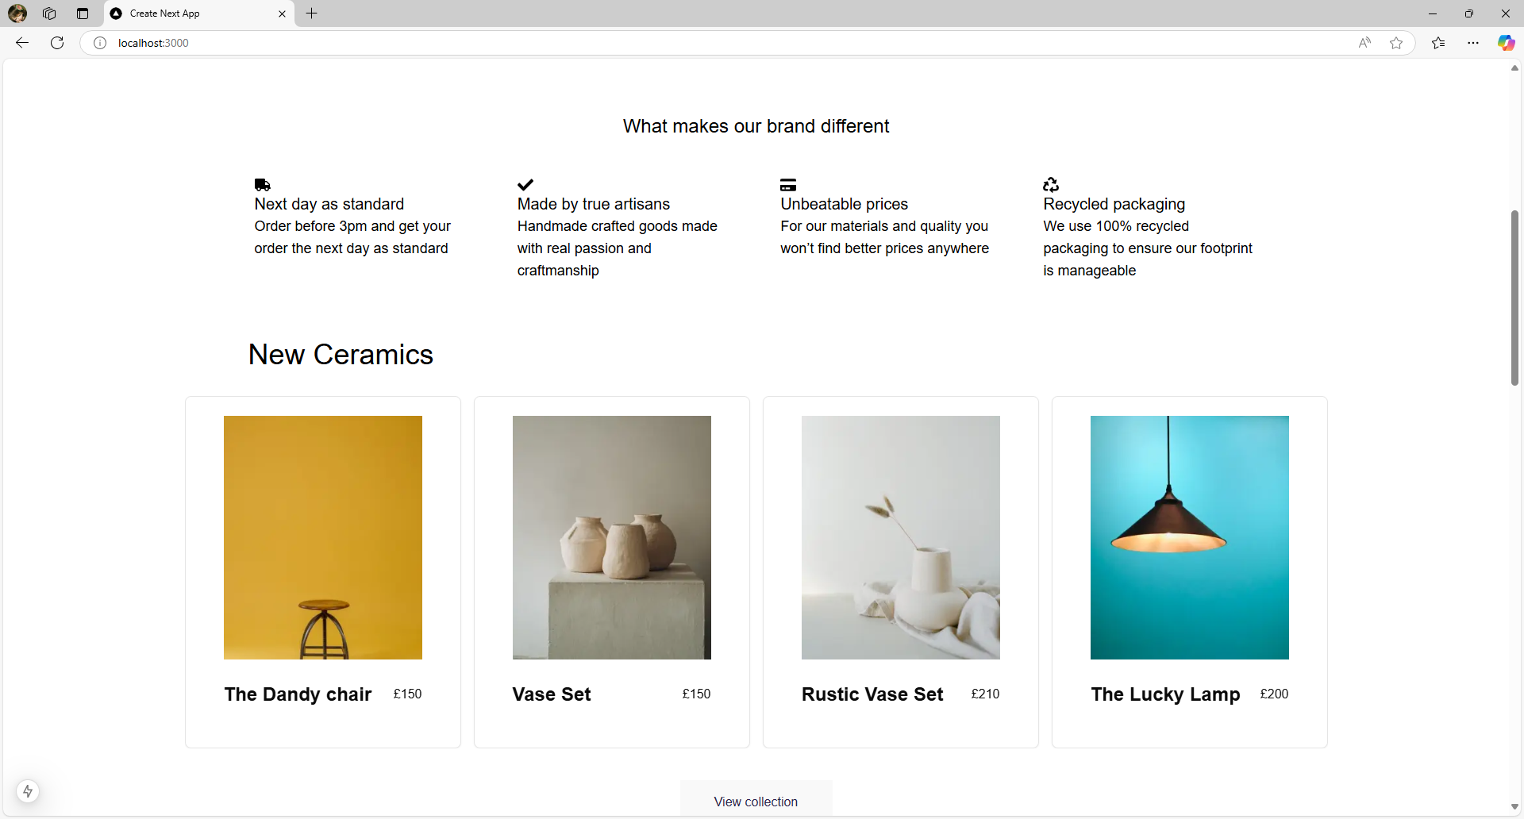

**Product Detail Page:**

A Dynamic product detail page that is fetching data from sanity on the base of slug field of products.

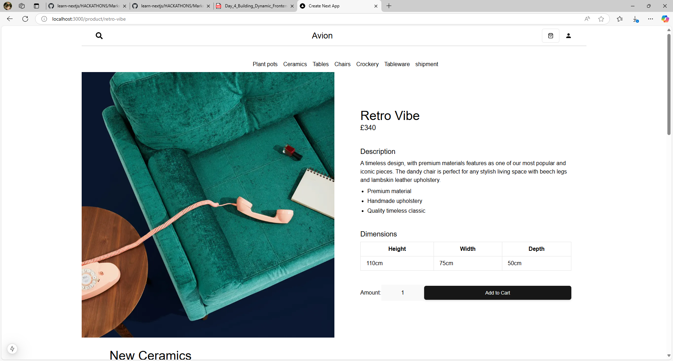

**Category Component:**

Category component that has a dropdown list to filter categories coming from sanity.

1. All products:

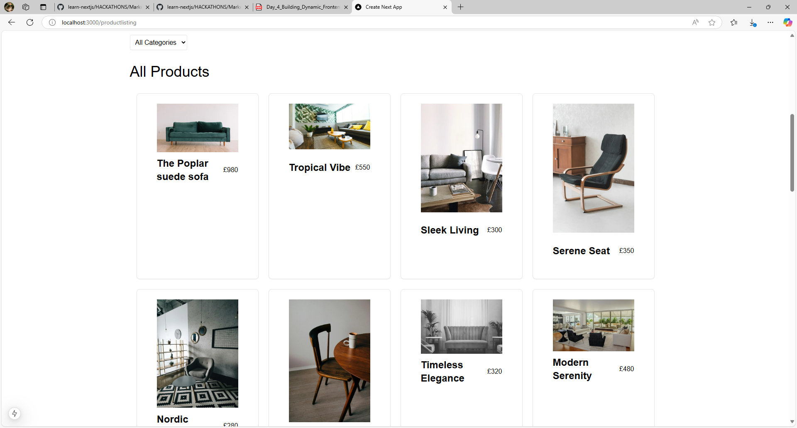

1. Ceramics

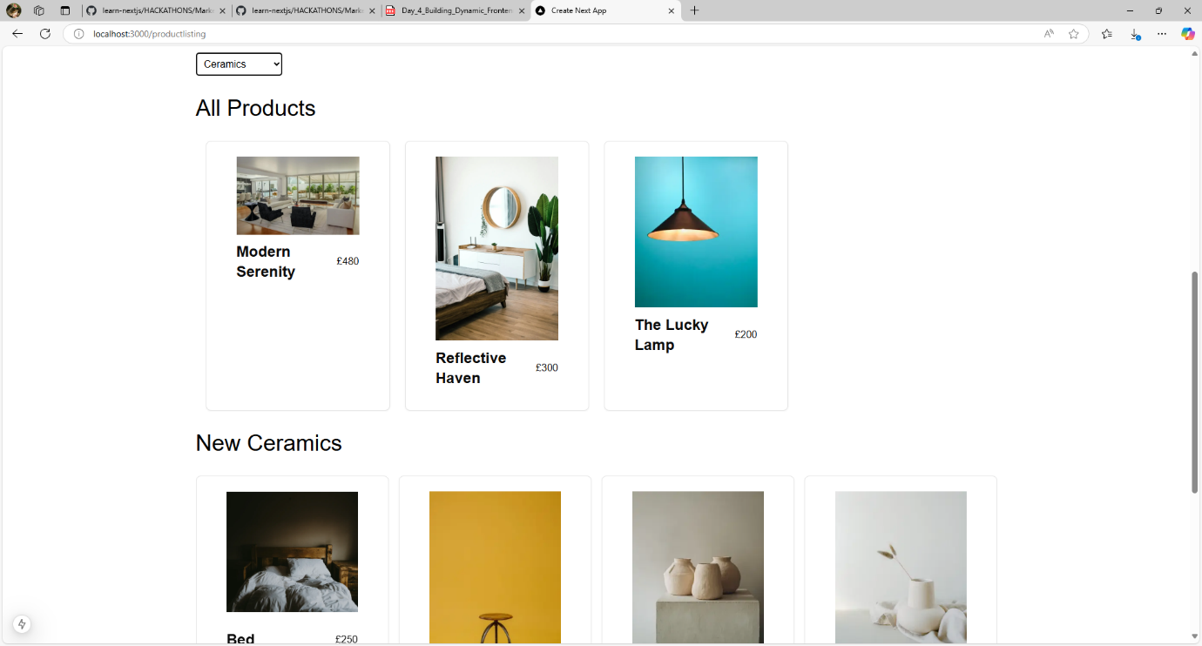

1. Chairs

1. Crockery

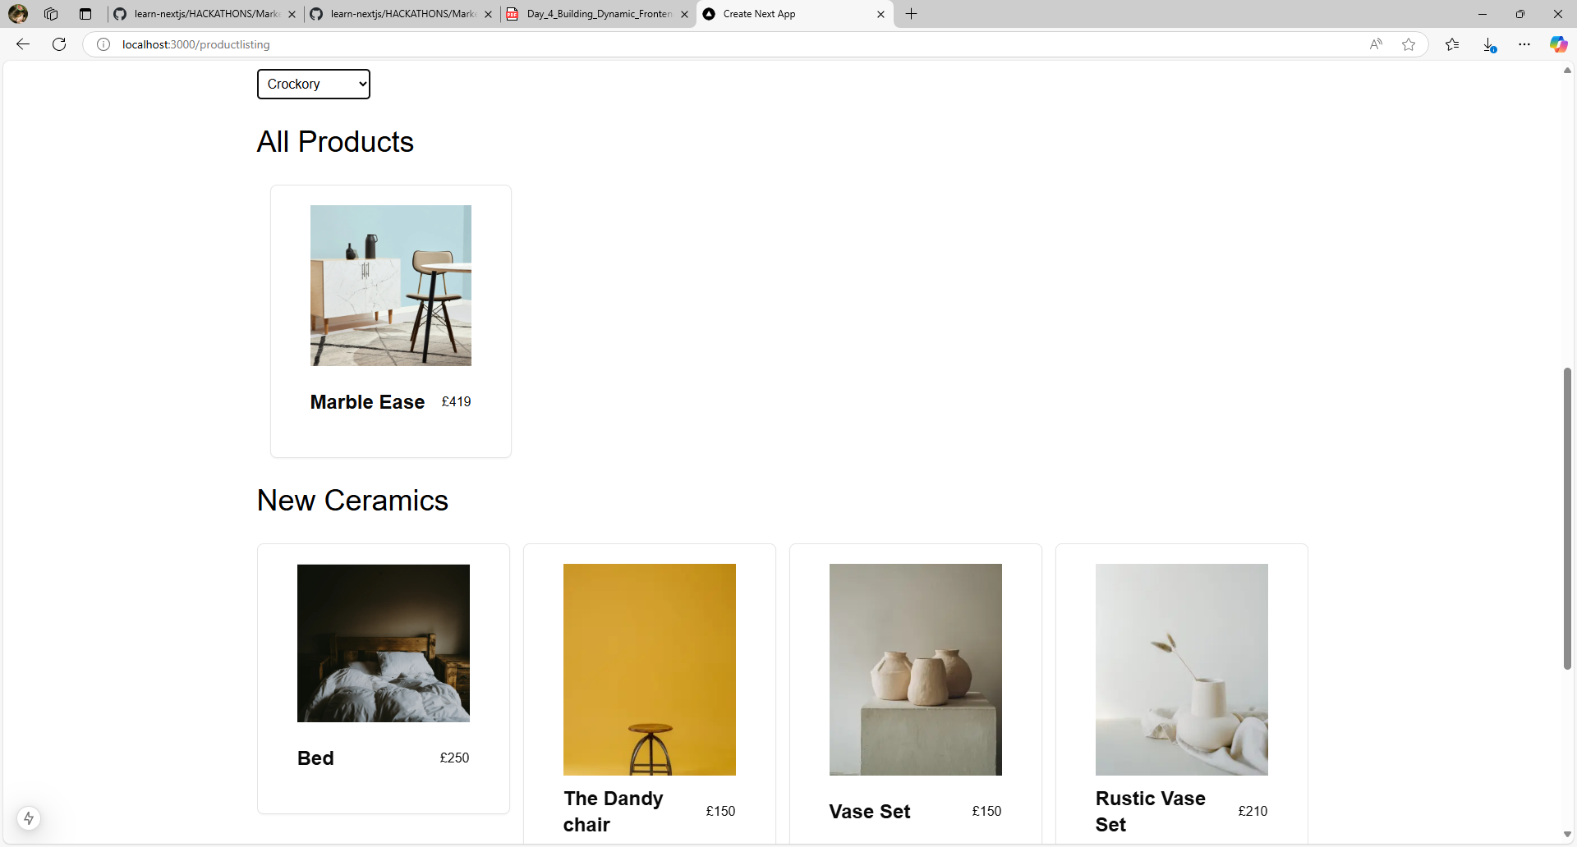

1. Cutlery

1. Plant pots

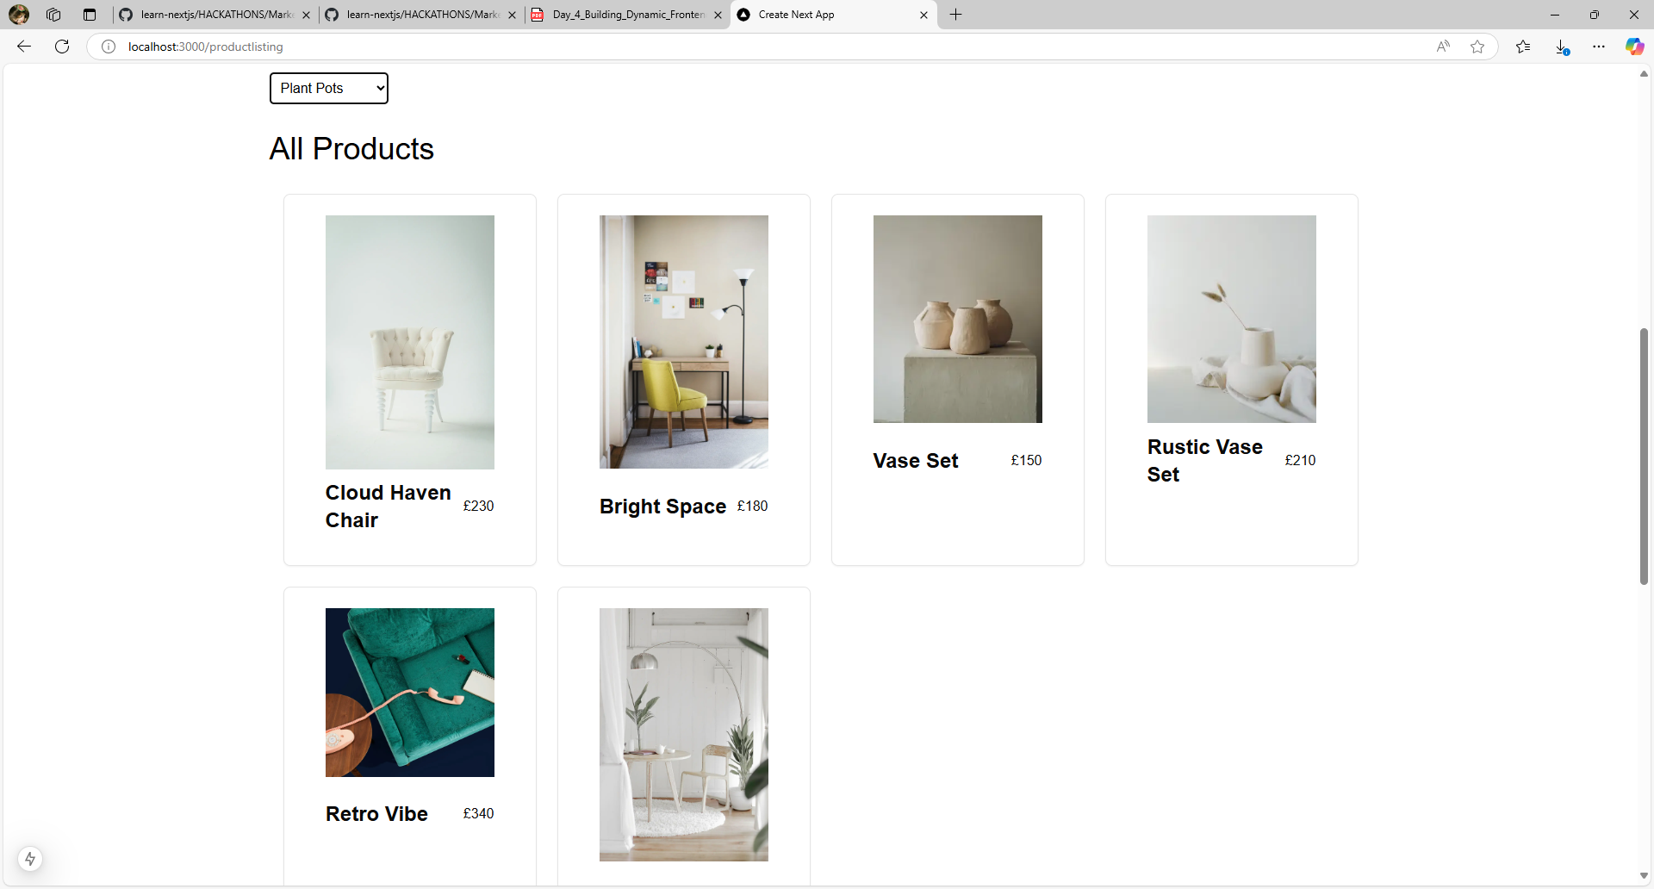

1. Tables

1. Tableware

**Add to Cart Component:**

ShoppingCartModal Component display on right side when click add to cart or cart button on navbar design using shadcn ui sheet and shopping cart hook.

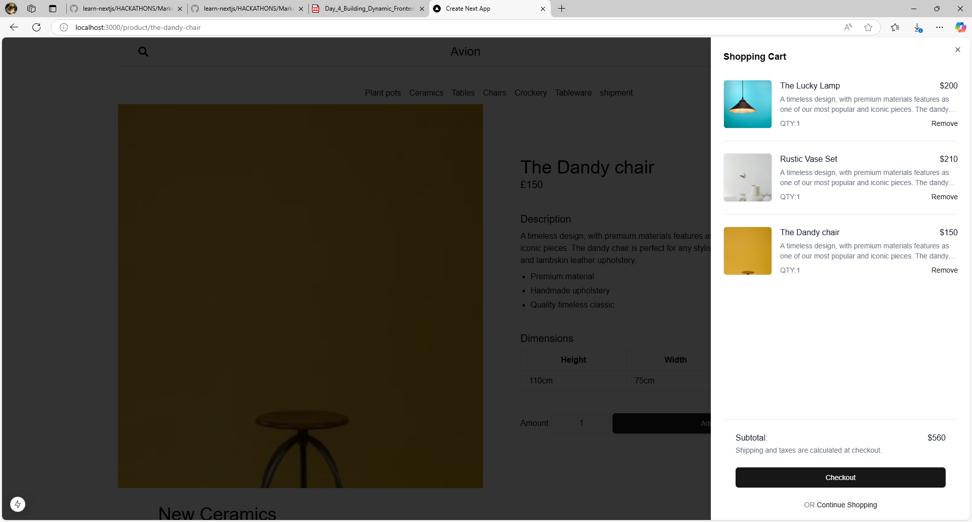

**Cart Page:-**

For add or subtract quantities of products that add in cart and show price of total products then subtotal of all products.

**Pagination:**

A pagination from shadcn ui added to my product detail dynamic route so we can check the detail of previous and next product through pagination:

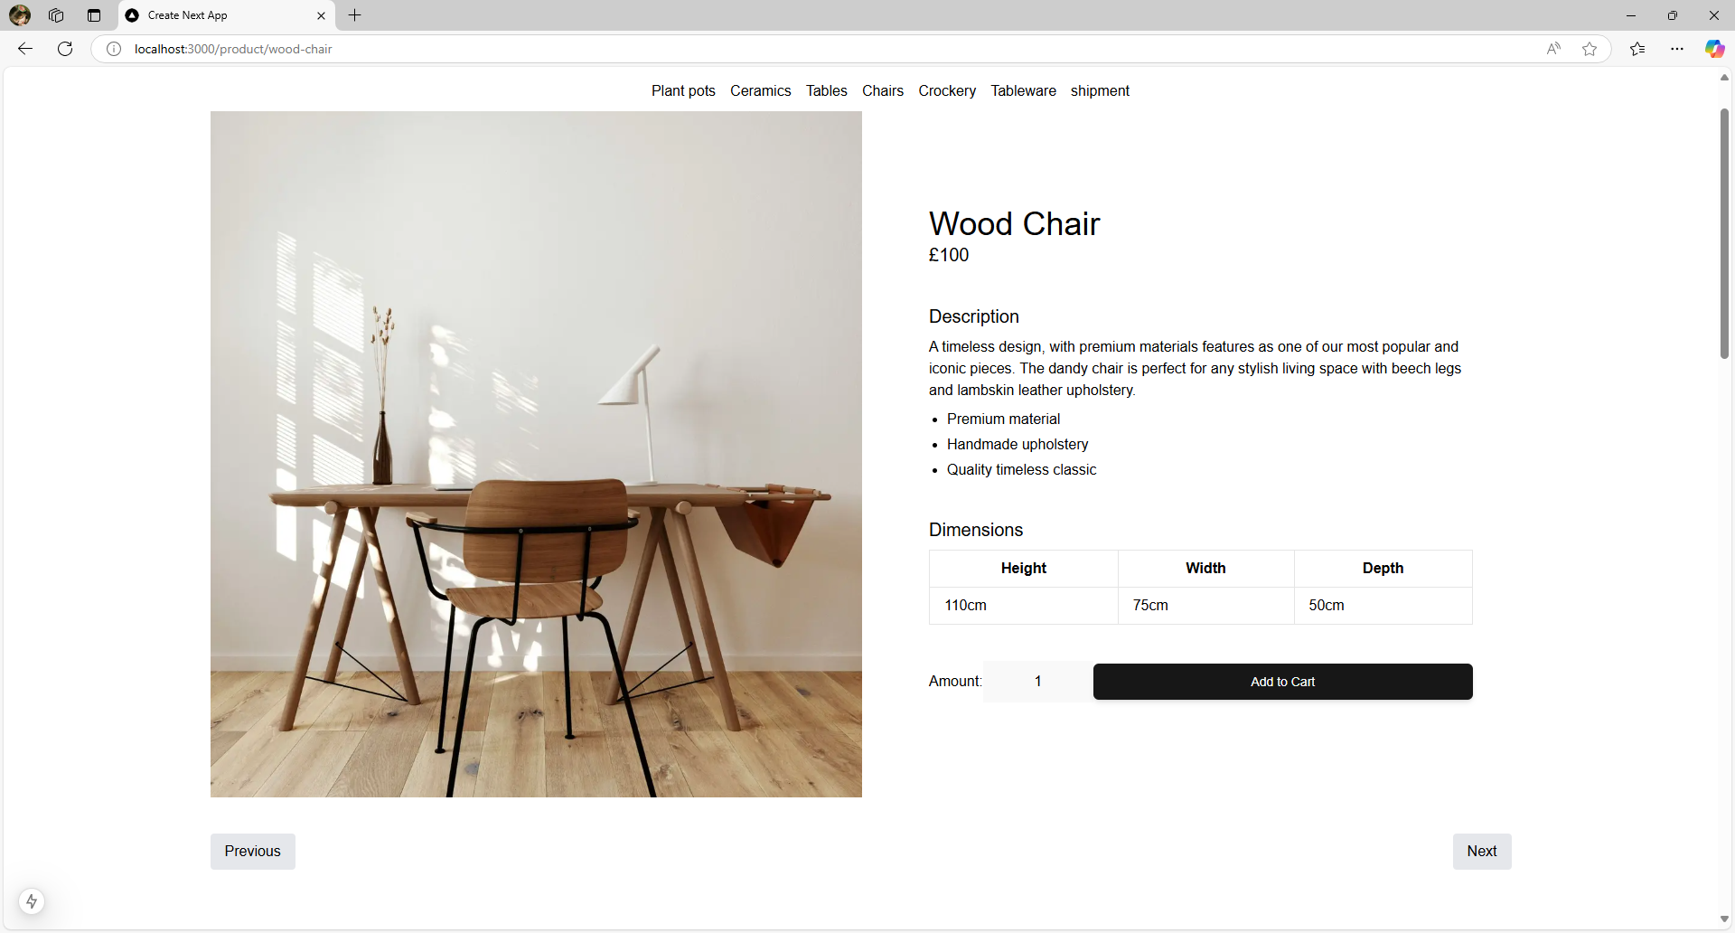

**Code Snippet for important components and pages:**

1. **Product listing with new ceramic tag:**

1. **Product detail dynamic route with pagination:**

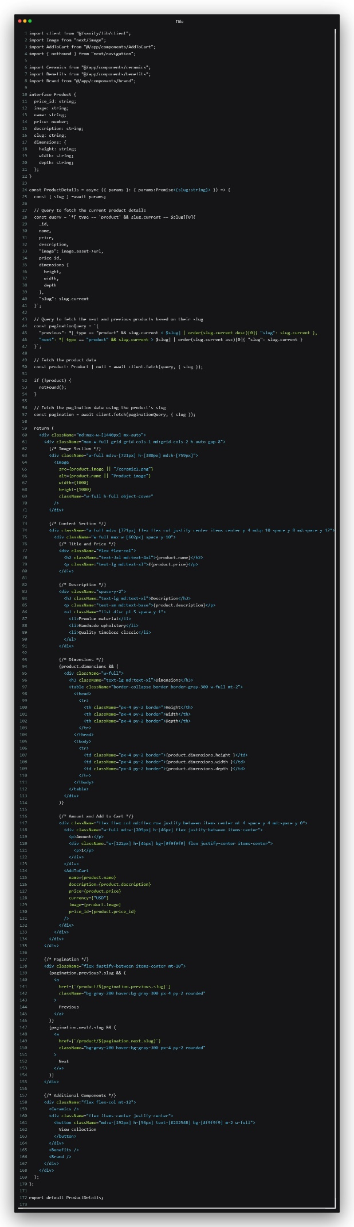

1. **Category component that filters category:**

**Conclusion:**

1. Here is the outcome of front-end ui that is rendered from the headless CMS i.e: sanity. I write groq for fetching products, product details , category and tags in different component and pages.
2. Challenges I have faced when filtering category on the base of slug then i filter with name in place of slug.
3. Secondly I have a challenge in implementing pagination in dynamic route of product detail.
4. At the end the outcome achieve from the 4th day is product listing, product detail dynamic route, category component and add to cart component and page.